First Annual

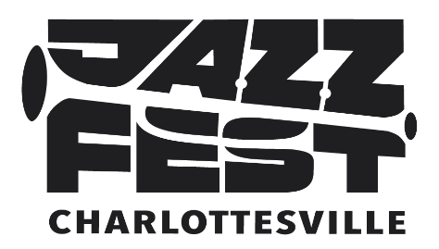

June 4-7, 2026

4-Day Jazz Festival on Downtown Mall Features 18 Area and International Artists
Plus “Young Lions of Jazz” Public School and Collegiate Musicians

WHAT: JazzFest 2026 presents club, concert, and featured performances by 18 nationally and internationally acclaimed artists and many of Charlottesville‘s finest musicians. International sensation and Charlottesville native, jazz vocalist Veronica Swift, headlines The Paramount Theater’s Saturday concert with special guest, Stephanie Nakasian, while “Young Lions of Jazz” from area schools perform at an earlier Matinee. Ting Pavilion’s free “Fridays After Five” event presents the U.S. Navy Band Commodores jazz ensemble and Richmond’s R4nd4zzo. The Front Porch and The Guild at Vault Virginia host multiple concerts with outstanding artists. The festival also offers a 2-night/multi-venue Club Circuit with no cover charges.
WHO: Presented by the Charlottesville Jazz Society and WTJU, along with C-VILLE Weekly, with support from Charlottesville GUIDE
WHEN: 6:00 p.m. Thursday, June 4 through 9:00 p.m. Sunday, June 7, with multiple daytime performances Saturday and Sunday
WHERE: The Paramount Theater, Ting Pavilion, The Guild at Vault Virginia, The Front Porch, The Whiskey Jar, Miller’s, Rapture
WHY: The Charlottesville Jazz Festival’s mission is to bring people together through the spirit of jazz—celebrating its culture and qualities of innovation, improvisation, and collaboration. JazzFest 2026 fosters those qualities for the benefits they offer both the art form and the community. JazzFest also supports area businesses on the 50th Anniversary of the Downtown Mall.
HOW: For interviews, please contact Steve Brecker, Media Relations, (757) 784-5530 mobile.

# # #

