Charlottesville Jazz Society Announces

First Annual

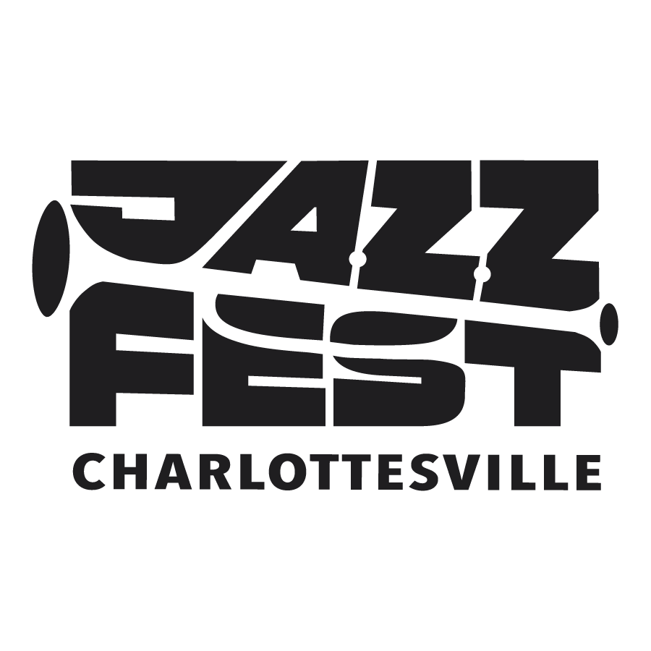

June 4-7, 2026

4-Day Festival Features Area and International Artists

May 31, 2026/Charlottesville, VA – The Charlottesville Jazz Society and WTJU are proud to present the first ever Charlottesville Jazz Festival, June 4-7, 2026. In conjunction with the 50th anniversary of Charlottesville’s Downtown Mall, JazzFest 2026 will offer audiences a chance to enjoy nationally and internationally acclaimed artists and many of Charlottesville‘s finest musicians over four days of club, concert, and featured performances.

Charlottesville native – and international sensation – vocalist, Veronica Swift, headlines the Festival at the Paramount Theater, Saturday June 6th, with special guest, Stephanie Nakasian. An All-Star collective of many of the region’s finest jazz artists, led by renowned Charlottesville trumpeter John D’earth, opens for Swift that evening.

JazzFest aims to be inclusive and accessible, with events such as Ting Pavilion’s free Fridays After Five big band concert featuring the celebrated U.S. Navy Band Commodores jazz ensemble and Richmond’s R4nd4zzo (“Randazzo”), delivering big band sound with a modern edge.

“We are both thrilled and honored that the ‘Commodores’ chose a performance at the inaugural JazzFest in Charlottesville amidst extraordinary demand for appearances during America 250 celebrations nationwide,” says Steve Brecker, a member of the JazzFest organizing team.

The Front Porch and Vault Virginia will host special events with outstanding artists, Royce Campbell and Ali Webb, and the festival will feature a two-night/multi-venue Club Circuit with no cover charges.

Youth inspiration and education is a key component of JazzFest, with area educators presenting both a multi-high school band and a middle school band for a Young Lions of Jazz Matinee at the Paramount June 6th. The Matinee also features a special presentation about young musicians and a performance by students in the UVA jazz music program. The Matinee includes an interactive jazz history event with musician, professor, and historian, Dr. Jeff Decker.

Charlottesville Jazz Society President, Gary Funston, notes, “First and foremost, this is a celebration of the immense pool of jazz talent that we are fortunate to foster here – and that people come from far and wide to enjoy. In fact, we’re reaching out to people from our immediate neighbors and area rural communities to audiences throughout the mid-Atlantic region.”

JazzFest 2026 has received funding support from Dave Matthews’ Bama Works grant program/Charlottesville Area Community Foundation, City of Charlottesville “Vibrant Community Fund,” The Caplin Foundation, John and Kate Byrne, Annette Osso and David Michelson, C-VILLE Weekly, Consignment House Gallery, Charlottesville GUIDE, The Nook, The Men’s & Boy’s Shop, and supporters of the Charlottesville Jazz Society.

Festival tickets are available here. JazzFest welcomes all to join the CJS mailing list and become a member of the Charlottesville Jazz Society. Listen to WTJU, 91.1 FM or wtju.net for the latest updates.

# # #

